Embleton Joint Burial Committee

GATEHOUSE COTTAGE, EMBLETON,
NORTHUMBERLAND

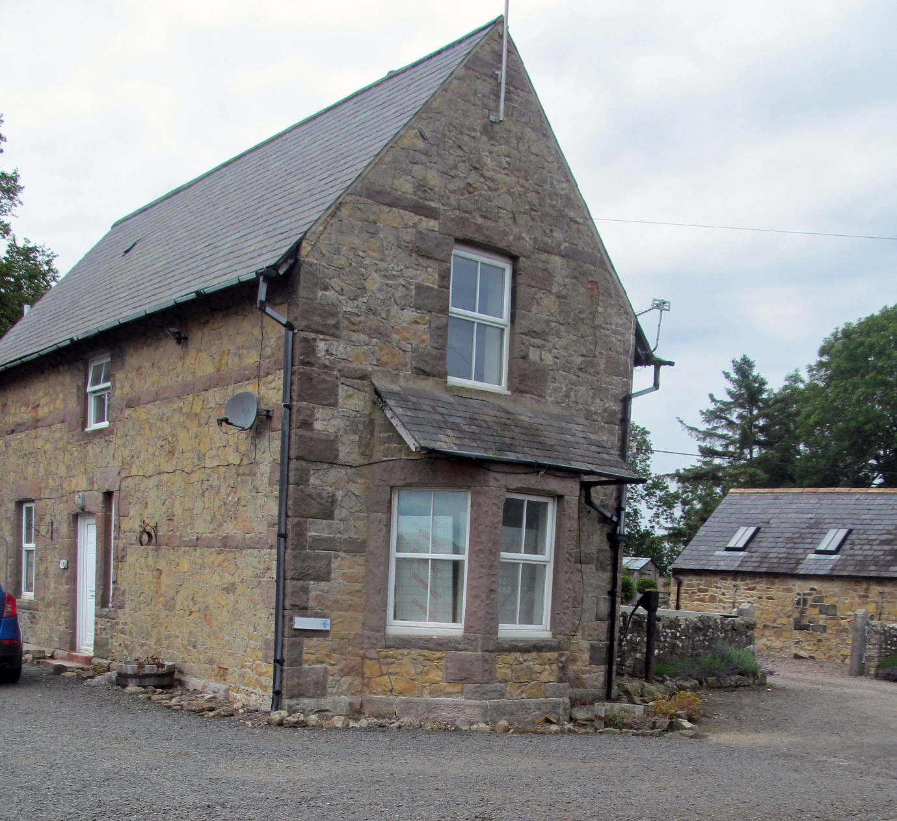
-
Gatehouse Cottage, Embleton is nearly ready for rental as an affordable home
The house (formally known as Cemetery House) has been in the ownership of Embleton Joint Burial Board (now Committee) since it was built in 1883 to provide a home for the cemetery caretaker/sexton. The Burial Board consisted of representatives
from Craster, Embleton, and Newton by the Sea Parish Councils

ln 2015 it was decided that the house was no longer needed for its original purpose.
and the house was put on the market for sale. Fortuitously, before the house could be sold,
the Burial Committee discovered that a new grant was available from Northumberland County Council (NCC) to help convert unused properties into affordable homes. The three Parish Councils, working through the Committee, drew up a plan to fully renovate the house
utilising the NCC grant and a Public Works mortgage. ln this way the house remained in the
Parish Councils ownership but helped meet the local need for affordable homes in the
face of ever rising numbers of second and holiday homes.

The £75,000 renovation is planned to be completed by the end of August with the house then being available to rent through NCC’s Homefinder scheme soon after. It has always been the intention of the Committee that the house should go to a family from one of the three parishes, or with some association with them. If you think that this two bedroomed detached house might be right for you, or somebody you know, then it is recommended that you register with the Homefinder scheme as soon as possible otherwise you will not be eligible to apply for it.

http://www.northumberlandhomefinder.org.uk/

